|  |
| --- |
|  |
| Distributed Solar Installation Monitoring |
|  |
|  |
| **Jayaprakash Krishnan** |
| **12/2/2017** |

Table of Contents

Introduction 2

Purpose 2

Scope 2

Overview 2

Architecture 4

Description 4

GSMS Core Component 5

GSMS Dashboard 5

Functionality 5

Operation 5

Interfaces 6

Attributes 6

GSMS components 6

GSMS Agent 6

Functionality 6

Operation 6

Interfaces 6

Attributes 6

OA&M components 6

Configuration Manager 6

Reporting system 7

Proposed GUI mockup 7

# Introduction

## Purpose

This document is the High-Level (Architectural) Design Document for Global Solar Monitoring System (GSMS). It presents a high level architecture that governs how functionality is divided across multiple functional components, and how those components interact.

One of the goals of this architecture is that it should be possible to deploy and run GSMS as independent applications.

It is intended that at an architectural level, there is sufficient flexibility to address not only those requirements expected by the current solar installations, but also the ongoing needs generated both by customers and by the marketplace.

## Scope

This document presents a top-level architectural design, identifying the components that comprise the overall GSMS offering, the role of each of those components in delivering functionality required of the system, and the interfaces provided by each component for interaction both between components within the system, and with external elements that the system is required to communicate with.

This document does not specify how each component is to be implemented. A separate design document(s) specific to each component identified in this architecture will reflect component-level decisions on technology direction and implementation.

## Overview

The architecture for GSMS separates functional components into four main categories:

* **GSMS core** components are responsible for maintaining customer information and current status of each of the installation.
* **GSMS agents** are customer agnostic. These components provide the complete site installation information, with the primary objective being to deliver information in the fastest possible time.
* **Application layer** components assist users with the creation and debugging of applications that run on GSMS infrastructure.
* **OA&M (Operations, Administration and Maintenance) layer** components provide the operational capabilities necessary to deploy and operate a GSMS system. This includes functionality related to configuration, provisioning, logging, reporting, monitoring, and management.

The following diagram illustrates the relationship between these categories. Note that component labels are provided for informational purposes, and may correspond to actual component names; note also that components shown do not represent the complete set of components in the architecture.

Web GUIs

Application Layer

GSMS

OA&M Layer

Reporting

GSMS CORE

GSMS Dashboard

CM

Nagios monitor

RT logs

This overview is intended to provide a very high level understanding of the architecture only. The following section below provides a complete description of the architecture.

# Architecture

## Description

The following diagram illustrates the architecture of Global Solar Monitoring System.

GSMS Dashboard

SSL

Global Messaging Bus

SSL SSL

Plugin

…

INSTALLATION SITE

Nagios Monitor

Config Manager

GSMS Agent

GSMS Agent

LDAP

NFS/HDFS

The description of each component covers the following areas:

* **Functionality** provided by the component, which explains the services that a component provides.
* **Operation** of the component, explaining the basic means by which the component offers its services.
* **Interfaces** to/from this component.
* **Attributes** of the component – in particular scaling, availability, redundancy/fault tolerance, and multi-tenancy.

# GSMS Core Component

## GSMS Dashboard

### Functionality

The Dashboard manages all installation and GSMS agent states. It provides the following functionality:

* Accepts new agent status information, queues them (if needed) and processes them based on priority rules configured.
* In order to make appropriate decisions regarding linking of an installation to an agent, the Dashboard maintains a list of customers and their agents.
* The Dashboard maintains statistics regarding the installations.

1. total amount of energy produced by the installation
2. amount of energy produced by each inverter
3. average charge amount of each battery in the system

* The Dashboard notifies the progress/status of the installations by generating events into the global Messaging bus.

### Operation

The Dashboard delivers its functionality using different algorithms that act on many different data structures to determine how installation data has to be handled. It is a robust multithreaded application. The Dashboard can be broadly separated into the following modules,

* the Installation Matching Framework
* the Statistics Collection Framework
* the Process Manager.

### Interfaces

The Dashboard interacts with other components mainly through JMS events.

### Attributes

Dashboard is a stateful component and is the focal point for providing GSMS resource management in the network. It is multi-tenanted in the sense that one Dashboard can service calls for multiple customer installations.

# GSMS components

## GSMS Agent

### Functionality

The GSMS Agent acts as a gateway between the Dashboard and the customer site installation. It translates all site data to dashboard specific messages. Similarly it receives configuration or action command events from the Dashboard and translates that to specific messages to be interpreted by the solar installation.

### Operation

The GSMS Agent subscribes to the global JMS broker and publishes data from the installation as well receives messages from the Dashboard. It filters the different events on the installation and responds to the ones that are relevant to it.

### Interfaces

It uses JMS messages as the interface to communicate with other components in the GSMS network.

### Attributes

There are two agents per installation in hot/standby configuration. Agents are a stateless component and hence the impact of it going down is almost negligible. They write to a persistent storage on a NFS mount or High Density data storage.

# OA&M components

## Configuration Manager

This component helps in adding/deleting new installations into the GSMS system. It also pushes updated configuration data to the globally distributed agents on the various installations.

## Reporting system

For historical reporting the data generated on each installation can be queued into an Elastic Search database through Kafka and used for analysis.

# Proposed GUI mockup

1. A user logs in with his/her credentials into the dashboard. Different user roles can have different access previleges.

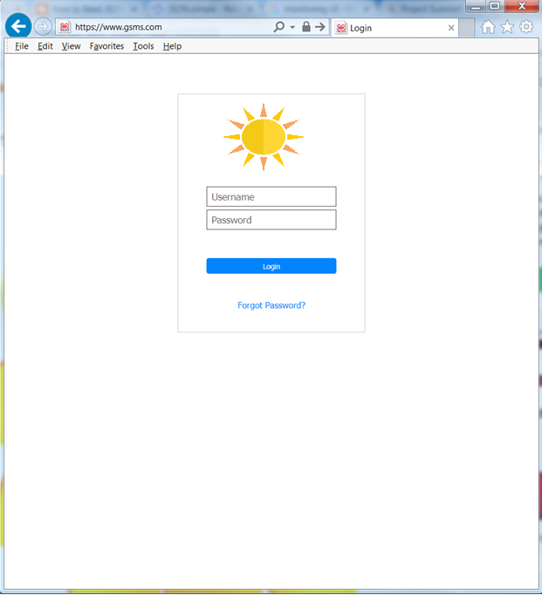

1. Once he/she is logged in successfully, they can see the overall summary of the installations.

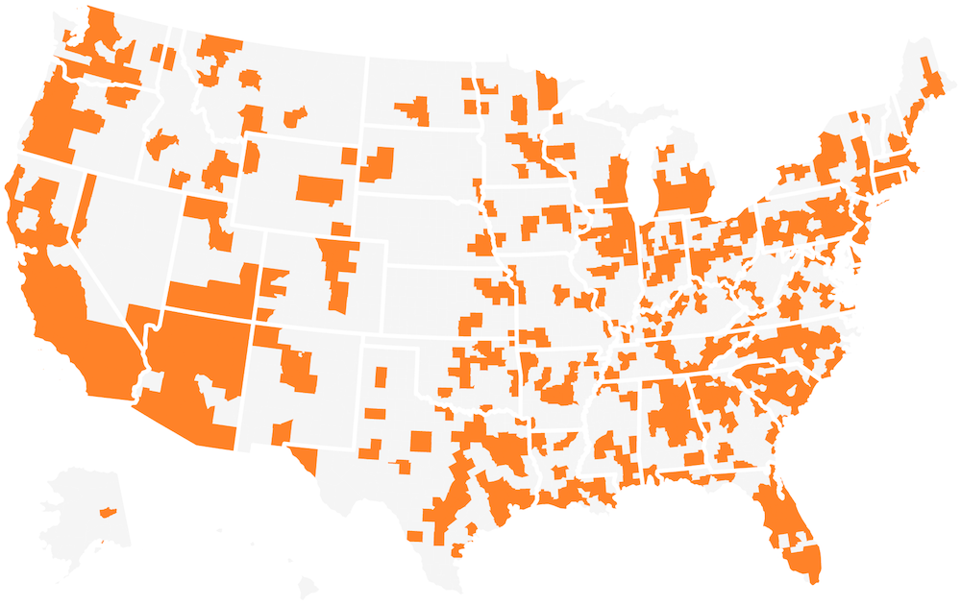

1. You can click on any region to find details about that installation

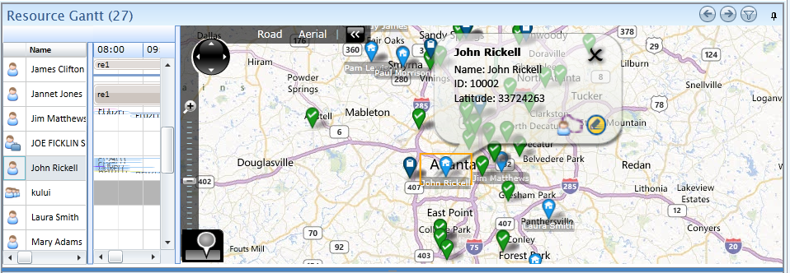

1. Drill down further per panel

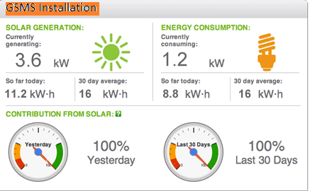

The general idea that we are trying to bring out is that a specific user of the GSMS system should be able to slice and dice to any granular level.

Some old school free hand sketches I tried ☺